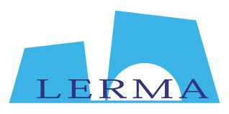

GeoHumanities
Bâtiment Porte T3, salle 001
Campus Schuman, Faculté ALLSH, Aix-Marseille Université

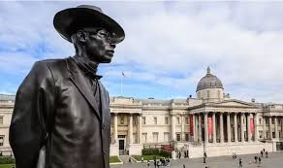

Malawi's John Chilembwe gets statue in London's Trafalgar Square (Sept. 2022)

Journée d’étude, vendredi 4 novembre 2022
Organisée par Camille Martinerie, Matthew Graves & Gilles Teulié (LERMA)

Un-covering Marginalised Pasts

9h30 Ouverture : Camille Martinerie, Matthew Graves & Gilles Teulié (AMU/LERMA)

Session 1 : Modératrice Camille Martinerie
10h00 Salhia Ben-Messahel (Toulon), “Austral-Asia: re-designing cultural landscapes.”

10h45 Discussion

11h00 Matthew Graves (AMU), “Turning Little England outside in: from James Boyce’s Van Diemen’s Land to Imperial Mud: The Fight for the Fens.”
11h45 Discussion

12h00 Déjeuner : Les Terrasses de Maxime
Session 2 : Modérateur Matthew Graves
13h30 Linda Pilliere & Karine Bigand (AMU), présentation de l’ouvrage collectif Memory and Identity: Ghosts of the Past in the English-Speaking World (Routledge, 2022).”

14h15 John Potts (Macquarie University), “Australian ghosts: representations of the past in Australia.” (presentation d’un chapitre de l’ouvrage)
14h45 Discussion

15h00 Kathy Luckett (University of Cape Town), “Haunting in a postcolony: race, place and intergenerational trauma on a South African campus.”
15h45 Discussion

16h00-17h30 Table ronde: Modérateur Gilles Teulié
“Spectral geographies, hidden histories – notions, readings, musings.”

Abstract

The first one-day conference in our Geohumanities seminar cycle 2022-23 explores marginalised histories that are currently being questioned in the light of post- and de-colonial approaches to the past. Uncovering pasts brushed aside or occulted in the wake of the colonial empires, whether in the former metropolitan centres, colonies of settlement, or colonial peripheries, implies a spatio-temporal rethinking of normative history as it was constructed and with it, a re-investigation and interrogation of canonical narratives, archival sources, and sites of memory long relegated to the sidelines. Uncovering such pasts has to do with how the colonial space was re-invented and re-mapped during the colonial and imperial periods, but also with how postcolonial space, whether material or immaterial, has since been reimagined and re-shaped. This includes the geopolitical power relationships that impacted knowledge production. By “un-covering” we refer to the deconstruction of hegemonic national and imperial narratives to reveal the pasts of alternative, subaltern or minority groups, with a focus on the micro-histories and complex cultural and political geographies that undercut the geometries of borders (across apartheid South Africa, partitioned Indian, or the Australian frontier, among others). The obscured or neglected character of knowledge production invites us to pay special attention to discourse and representations, but above all we look to investigate the agencies behind the reproduction of social power relations. Who were the actors of the marginalised, the hidden, and the untold? And who is now interrogating the ghosts of these troubled pasts? Contributors will draw from an interdisciplinary range of methodologies and conceptual tools to examine the un-covering and foregrounding of marginalised pasts through the prisms of popular media, post- and de-colonial political discourse and counter-memorial practice.

Convenors
Matthew Graves, Camille Martinerie, Gilles Teulié
GeoHumanities research seminar and network, LERMA, Aix-Marseille Université.

